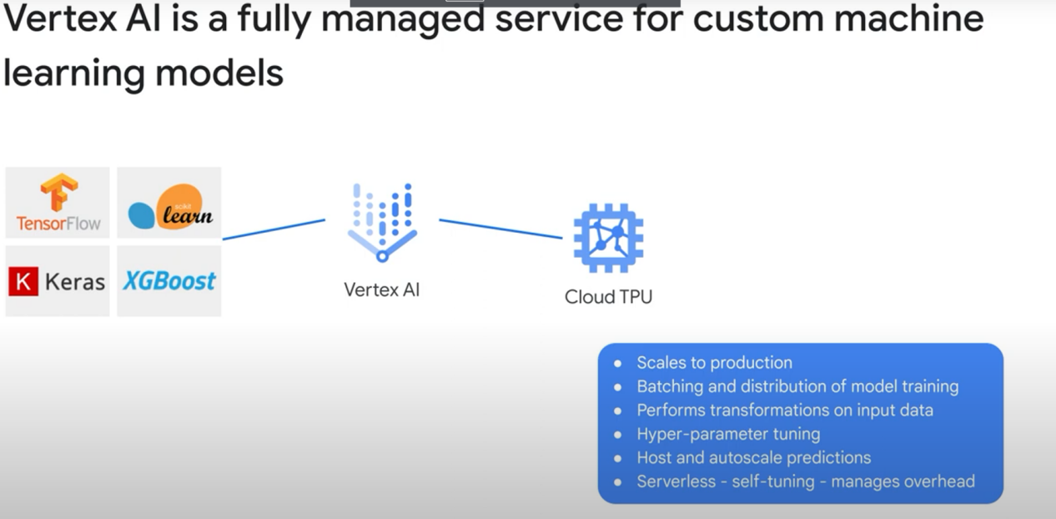

**ML pipelines:** A piepline is a group of steps, with each step taking the output of the previous step as an input. An ML pipeline automates the training and deployment of models.

Example of a pipeline:

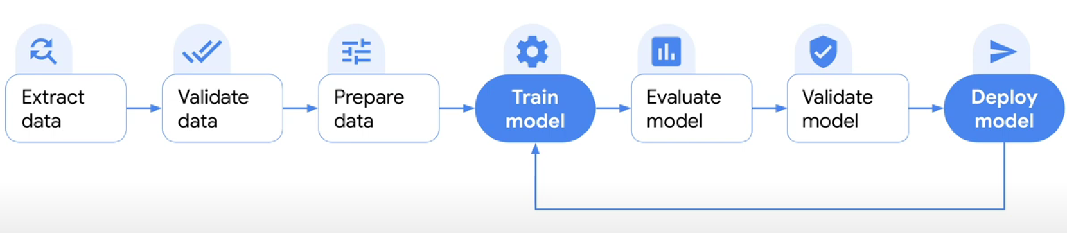

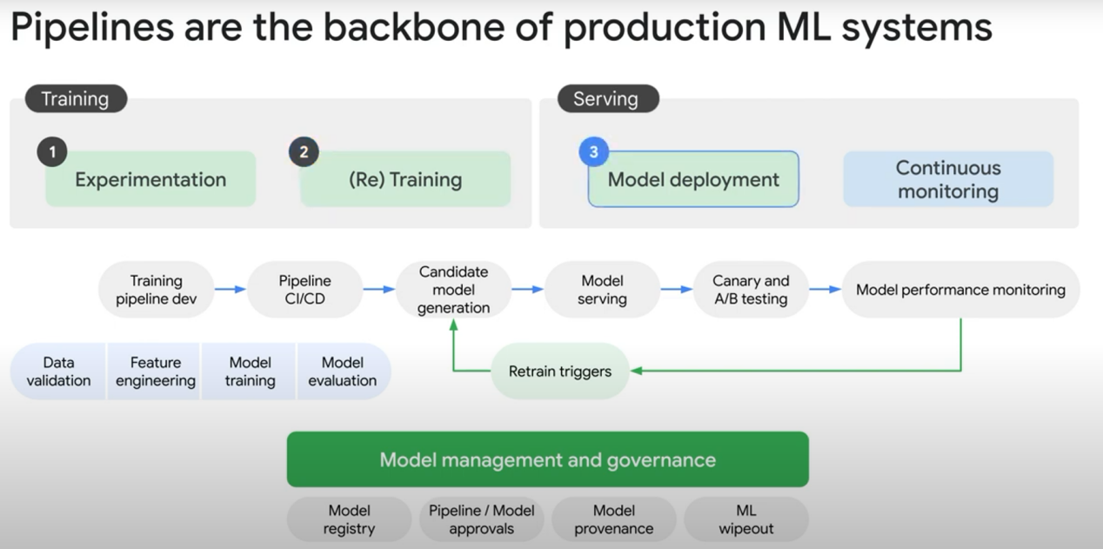

**Canary testing:** refers to testing a new software version or a new feature with real users in a live (production) environment

**A/B testing:** You have 2 versions of the data, and you try to train your model with data A and data B. Then you figure out which was the better option.

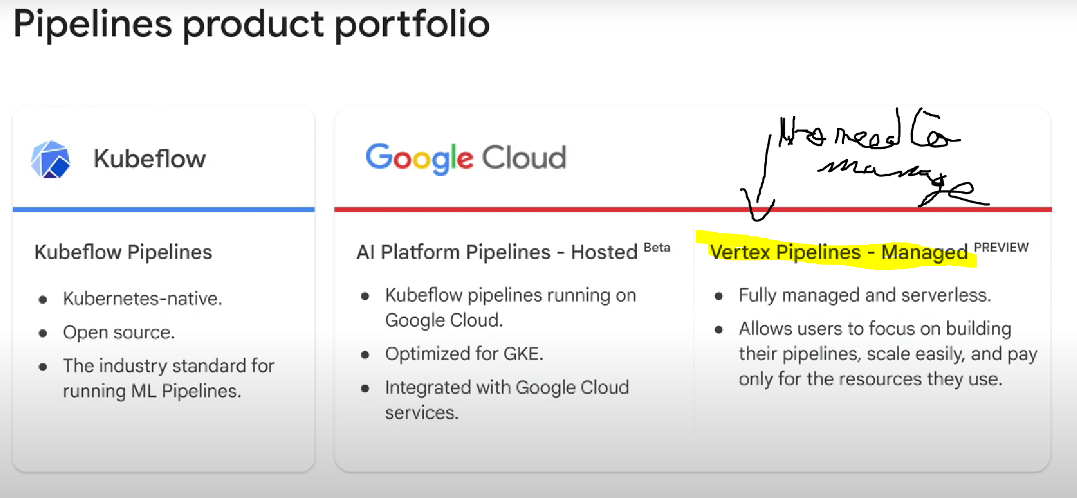

Vertex AI will create and manage the kubernetes clusters for you.

